PRESENTS

CAREER NUGGETS - THE ACADEMY

WORKPLACE EXCELLENCE PROGRAMME
2021 - 2022 BROCHURE

“We are delighted to welcome you to our Academy, Workplace Excellence Programme. Our aim is to educate, empower and enlighten the BME community, to contribute towards workplace excellence and diversity for the shared benefit of our society.”

Morenike Ajayi (Founder)
CAREER NUGGETS - THE ACADEMY
WORKPLACE EXCELLENCE PROGRAMME

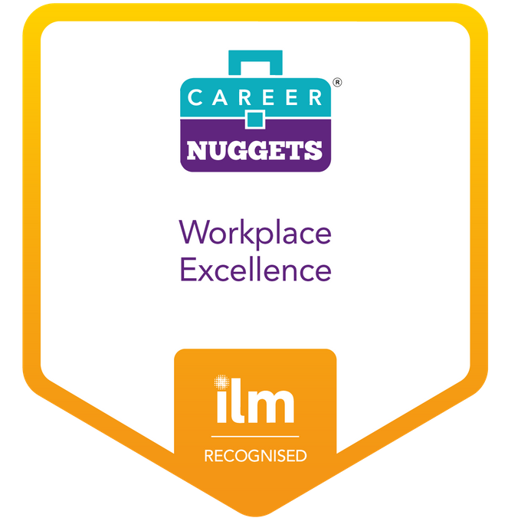
Contents
1. INTRODUCTION 4
2. BACKGROUND 7
3. CURRICULUM OVERVIEW 8
4. REGISTRATION & JOINING INSTRUCTIONS 9
5. THE ACADEMY - FULL PROGRAMME (OVERVIEW) 10
6. THE ACADEMY - LITE PROGRAMME (OVERVIEW) 11
7. THE NETWORK & ALUMNI - VALUE PROPOSITION 12
8. OUR TESTIMONIALS 13
9. CURRICULUM VALUE ADDED 14
10. OUR APPROACH 16
11. YOUR BENEFITS 18
12. TIMETABLE & OUTCOMES 20

INTRODUCTION

Who We Are?

Career Nuggets Academy is an information support hub based in London, UK. Our mission is to develop workplace excellence for individuals of Black Minority Ethnic (BME) background. We work with a diverse group of individuals ranging from final year university students, to young graduates and professionals seeking career advancement as well as those seeking influence through management and leadership opportunities in their careers.

We are enthusiastic about fully developing and harnessing the length and breadth of capabilities in our community through shared ideas and experiences imparted by our experienced experts and mentors. Our programmes foster workplace excellence and enable people to, thrive, excel, advance and derive fulfilment in their chosen careers. By doing this, we seek to create positive change, diversity, and inclusion for the mutual benefit of society.

What We do?

Career Nuggets is run by career development experts who have excelled in their professions and are willing to mentor ambitious individuals to attain the peak of their careers. By leveraging our diverse and skilled network of accessible mentors from various fields of expertise, we connect ambitious individuals to mentors, people, resources, and experts in disciplines that will inspire, position and direct them to succeed in their careers. We also work with final year university students on workplace employability as part of a leadership module. We do this by preparing them for the marketplace and by equipping them to thrive and excel in the workplace.

Our Goal

Our goal is to build a digitally enabled information support academic hub to empower, educate and enlighten the BME community to fully achieve their career dreams. Our programme is aimed at developing and upskilling the BME community, thus providing people with the tools they need to thrive. Career Nuggets focuses on developing a pipeline of talents. In doing this we are establishing a healthy flow of high performing BME middle, senior management and leadership professionals that is better reflective of the UK society in the public and private sectors.

Our Approach

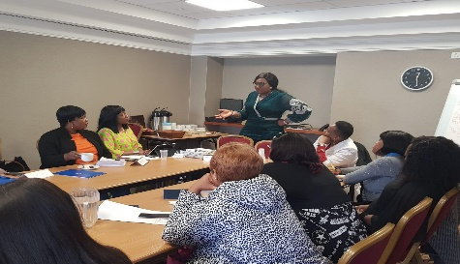

We deliver a continuous learning and development programme that empowers, educates, and enlightens the BME community. We inspire and mentor people to realise their full potential by preparing them and upskilling their talents for continuous excellence in the workplace.

We do this by coaching, mentoring and empowering professionals to develop the required confidence to seize opportunities and apply for senior management and leadership roles in the workplace. Above all we drive diversity, inclusion and help improve an organisations overall performance. Our activities contribute to empowering the BME community to realise their full potential.

The Programme
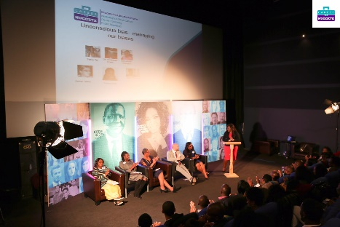

The programme is delivered by our founder and an accessible pool of experienced mentors and key speakers. We provide expert CV advice, knowledge, information, career mentoring, training, and coaching. We do this by providing a formidable platform and an enabling environment where a pool of mentors and role models can have a seamless connection with ambitious mentees, and peers at our training, seminars, and workshops.

Our Impact

Our numbers speak for itself. We have empowered 2,000+ professional recipients, secured 50 work placements and showcased 20 positive role models. We have supported 50 individuals in securing roles and delivered 3 accelerate mentoring groups for 60-70 professionals. 150 people have registered for our December 2020 virtual event. During Covid19, 10 families were supported by Career Nuggets, 15 individuals were mentored, and 8 mentees have secured jobs since the pandemic. To date 48 episodes of our 4-x weekly career programme have been successfully aired on television on Sky Channel 193 Vox Africa.

BACKGROUND

Accelerate Mastermind
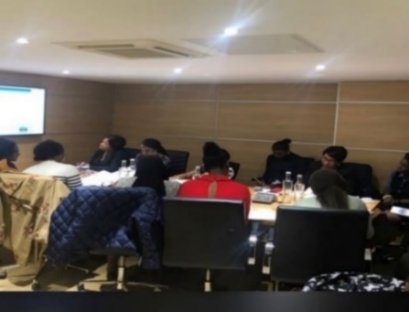

The academy began with Accelerate Mastermind, an 8-week mentoring and accountability programme. Accelerate Mastermind is an intensive career coaching and mentoring programme designed to improve career progression. The programme is designed to help mentees excel and thrive successfully in their careers.

Accelerate comprises coaching sessions on goal setting, communication skills, networking methods, access to inspirational role models, CV reviews and interview preparation. Our mastermind sessions and hot seats involve direct access to generous high-level experienced mentors from different industries. Our accountability system ensures that no one is left behind, and it has achieved great results for many professionals.

Our Research

Over 30% of BME employees reported that they had been overlooked for promotion.
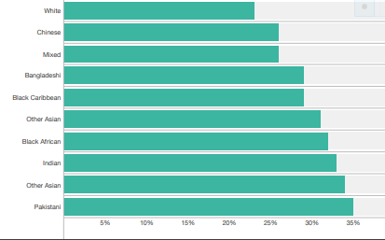

Source: Gov.UK McGregor-Smith Review

The academy was borne out of research and engagement with other bodies, universities, organisations and corporate BME networks. Results from the research and interviews conducted revealed:
- A gap in BME management and leadership in the community
- The need for more effort on BME integration in the workplace
- The requirement to support more companies with their Diversity & Inclusion (D&I) strategy
- Results conducted on 2000+ professionals revealed significant gaps in soft skills.

CURRICULUM OVERVIEW
Programme Summary
Career Nuggets - The Academy is a mentoring, mastermind, accountability, and continuous development programme. It is an intensive career coaching, mentoring, management, and leadership development programme aimed at workplace excellence and accelerating career progression.
Curriculum Overview
- Career Planning - Developing a career vision board. Setting Your Career Goals & Your Purpose
- Maximising Career Opportunities - Transferable Skills, Career Options, Career Transitioning
- Leadership & Managing - Leadership Styles, Managing Up/Down, Leading Leaders
- Leadership Mindset - Thinking Traps & Hacks, Strategic Thinking, Self-Limitation & Resilience
- Visibility in the Marketplace - Perception Management, Adding Value, Networking Effectively
- Communication Skills - Delivering with Impact, Reporting & Resenting, Top-Notch Elevator Pitches
- Conflict Management - Office Politics, Differences of Opinion, Influencing & Persuasive Skills
Dates
- Academic Year: 2021/22 Dates: 15th February / September 2021
Programme Overview
- Part 1 - 7 weeks of lecture
- Part 2- 1 week (group / personal case study)
- Weekly Inspirational Keynote Speakers and Panel Q&A Sessions
- Case Study Output / Career Guide
- Completion - Closing Ceremony | Meet & Greet Session | Corporate Sponsor Speech
- Conclusion | Graduation Ceremony | Certification | Continued Professional Development Support
The Programme Includes Value Added & Benefits
- Career Goal setting
- CV Review & Skills gap analysis, Access to our 2000+ Network
- Career Improvement plan, Coaching, Counselling, Mentoring & Accountability
- Interview preparation & Continued Professional Development Opportunities
- Networking Effectively, Professional Etiquette, Presentation & Decorum
- Transferable Skills, Career Options & Transitioning
- Bullying, Adding Value, Recognition & Reward
- Being Headhunted, Branding & Positioning
- Imposter syndrome, Stepping Out of Comfort Zone, Dealing with Self Limitations
- Delivering with Impact, Influencing & Presenting Skills & Top-Notch Elevator Pitch

REGISTRATION & JOINING INSTRUCTIONS

Start Dates: 15TH February
Day & Time: Wednesday 6:30-8:30 pm (London GMT)
Location: Online Virtual (All Details are Subject to Further Confirmation)
Programme Overview
- Part 1 - 7 weeks of lecture
- Part 2- 1 week (group / personal case study)
- Weekly Inspirational Keynote Speakers and Panel Q&A Sessions
- Case Study Output / Career Guide
- Completion - Closing Ceremony | Meet & Greet Session | Corporate Sponsor Speech
- Conclusion | Graduation Ceremony | Certification | Continued Professional Development Support

Full Programme Pricing
- £249.99 Full Programme (x10 attendees discounted to @ £2,000)
- £99 Annual Membership Fee (On completion) - Provides access to all events at a discounted rate

Registration & Contact Details
- E: info@careernuggets.co.uk | W: https://www.careernuggets.tv | M: +44 (0) 7585 007 406
- L: https://www.linkedin.com/company/career-nuggets/ | T: https://twitter.com/careernuggets
- F: https://www.facebook.com/careernuggets | I: https://www.instagram.com/careernuggets/
- Career Nuggets Seeks to | Educate | Inspire | Enlighten

THE ACADEMY - FULL PROGRAMME (OVERVIEW)
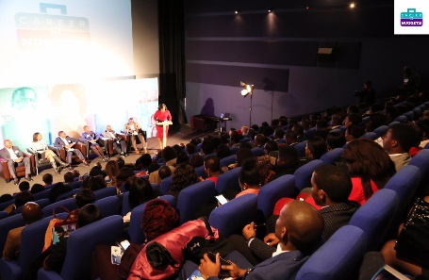

Start Dates: 15TH February
Day & Time: Wednesday 6:30-8:30 pm (London GMT)
Location: Online Virtual (All Details are Subject to Further Confirmation)
Course Outline
- Part 1a - 3 weeks of lecture
- Part 1b - 1 week (assignment case study)
- Part 2a - 3 weeks of lecture
- Part 2b - 1 week (case study presentation)
- Weekly Inspirational Keynote Speakers and Panel Q&A Sessions
- Case Study Output / Career Guide
- Completion - Closing Ceremony | Meet & Greet Session | Corporate Sponsor Speech
Pricing
- £249.99 Full Programme (Groups of x10 discounted at £2,000)
- £99 Annual Membership Fee (On completion) | Provides access to all events at a discounted rate

Value Added & Benefits
- Founder - Vested Interest in alumni life-long success
- Supervisors & Mentors to support your Case Study
- Career Nuggets Network - Inclusive & Accessible Network
- Course Materials Included
- Mentorship on career Next Steps
- Coaching on CV and medium to long-term goals

Registration & Contact Details
- E: info@careernuggets.co.uk | W: https://www.careernuggets.tv | M: +44 (0) 7585 007 406
- L: https://www.linkedin.com/company/career-nuggets/ | T: https://twitter.com/careernuggets
- F: https://www.facebook.com/careernuggets | I: https://www.instagram.com/careernuggets/
- Career Nuggets Seeks to | Educate | Inspire | Enlighten

THE ACADEMY - LITE PROGRAMME (OVERVIEW)

Start Dates: 15TH February
Day & Time: Wednesday 6:30-8:30 pm (London GMT)
Location: Online Virtual (All Details are Subject to Further Confirmation)
Course Outline
- Part 1a - 3 weeks of lecture
- Part 1b - 1 week (assignment case study)
- Part 2a - 3 weeks of lecture
- Part 2b - 1 week (case study presentation)
- Weekly Inspirational Keynote Speakers and Panel Q&A Sessions
- Case Study Output / Career Guide
- Completion - Closing Ceremony | Meet & Greet Session | Corporate Sponsor Speech
Pricing
- £124.99 Lite Programme Part 1a and 1b
- £124.99 Lite Programme Part 2a and 2b (Part 2 is Optional for the Lite Programme)
- £99 Annual Membership Fee (On completion) - Provides access to all events at a discounted rate

Value Added
- Founder - Vested Interest in alumni life-long success
- Supervisors & Mentors to support your Case Study
- Career Nuggets Network - Inclusive & Accessible Network
- Mentorship on career Next Steps
- Coaching on CV and medium to long-term goals

Registration & Contact Details
- E: info@careernuggets.co.uk | W: https://www.careernuggets.tv | M: +44 (0) 7585 007 406
- L: https://www.linkedin.com/company/career-nuggets/ | T: https://twitter.com/careernuggets
- F: https://www.facebook.com/careernuggets | I: https://www.instagram.com/careernuggets/
- Career Nuggets Seeks to | Educate | Inspire | Enlighten

THE NETWORK & ALUMNI - VALUE PROPOSITION

- A diverse Network of skilled BME Professionals
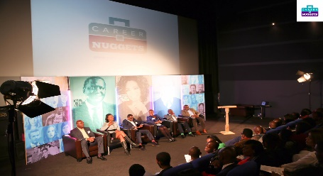

- Access to senior management and leadership expertise

- Peer to peer professional support for real-life work situations and case studies

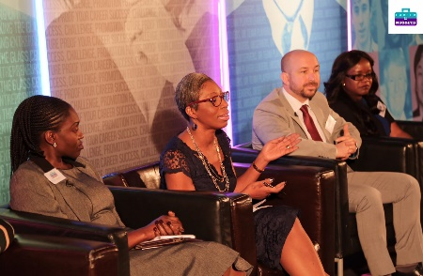
- An accessible pool of experienced mentors & expert coaches

- Access to our continuous professional development, training, and events

OUR TESTIMONIALS

Networking
“Access to Career Nuggets 2000+ Network has been invaluable. I would have been unable to find this valuable network of experts who have helped my career on my own.” - Yewande Ojo

Coaching
“Career Nuggets helped me with my CV review. They provided 1-2-1 career coaching sessions and mock interviews. They excelled at successfully helping me secure a new job.” - Ayo Ayoola

Mentoring & Counselling
“Career Nuggets reviewed my CV and with intensive coaching they counselled me and gave me the confidence to successfully move from a middle to senior management role.” - Abby Akinola

BME Career Development

“Career Nuggets are real pioneers in the BME community. I fully recommend them for anyone who wants to break barriers in their career.” - Elizabeth Dada

CURRICULUM VALUE ADDED

Our Inclusivity

Our inclusivity makes us unique. Our programme is open to all motivated professionals prepared to give full attention and follow guidance, with strict compliance to see a difference and obtain tangible success.
Our Accessibility
Our programme and hotseats give you direct access to generous high-level mentors from diverse industries and backgrounds. Plus, personal access to our founder to gain unique insight into your specific career goals.
Our Promise
We are confident that you will be satisfied. The course is delivered in groups of only 15. We roll up our sleeves and go on this professional journey of self-discovery and realisation with you.
Our Interactive Programme

Our interactive online full programme comprises part 1 & 2. 6 weeks of virtual training workshops fortnightly from 6.30 - 8.30 pm on Wednesdays and includes 2 weeks of group or personal case study and presentation.
Our interactive online lite programme comprises 3 weeks of virtual training workshops, fortnightly from 6.30 - 8.30 pm on Wednesday and includes 1 week of group or personal case study.
Our live webinars provide you access to industry experts, a case-based project, certification, and an annual graduation ceremony.
Our Free Strategy Call

This personal access to the founder will enable us gain insight into your specific medium to long term career goals and aspirations.
Our Network
Our network is accessible, and we encourage the building of peer to peer groups amongst participants and connections in an informal setting.
Our Coaching
This will be done after the training sessions at a time and place that is convenient for everyone.
Our Expert Mentors
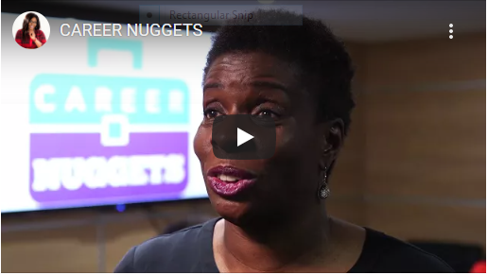

Knowledge from our programme is from real-life BME experiences that cannot be found in books, on YouTube or at seminars. These are trusted methods, true insight and tactics acquired over years from the workplace.
Our Tailored Support
This will help gain and develop clarity on the types of jobs, sectors and industries that best suit your personality and the things that are important to you. This includes your LinkedIn, personal brand, CV, and interview tips.

OUR APPROACH

We Provide a Support Hub

We provide a support in the following areas:

- Help in setting and attaining career goals
- Support in achieving what you want for your career
- Reviews to help with identifying your career and skills gap
- Intensive coaching to help in obtaining your dream job
- Confidence to attain a higher job, role, or proportionate reward
- Support in growing and fulfilling your full career potential

We Mentor

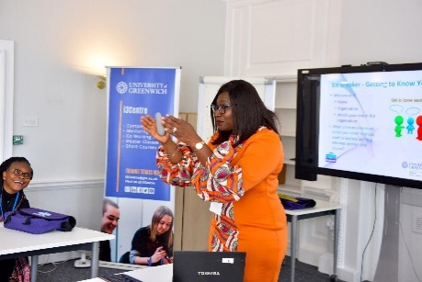

We mentor in the following ways:

- Mentoring and help with changing your current job, career path or industry
- Coaching to support you in making tangible career progress
- Coaching on moving to the next level in your career
- Coaching for achieving success in job applications
- Counselling and mentoring to gain respect and recognition at work
- Empowerment to become better appreciated as a valuable member of your team

We Educate

Our approach to educating includes but is not limited to the following:

- Providing insight for developing the “know-how” to excel
- Creating opportunities for acquiring more experience
- Providing platform for building on your qualifications
- Teaching techniques for strengthening your foundations
- Delivering training to upgrade qualifications
- Tutoring on methods for acquiring the know how to get any job or position

We Empower
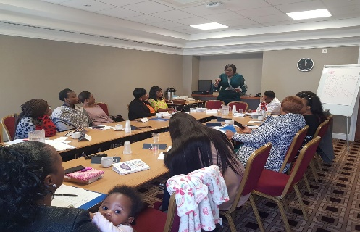

We empower communities by doing the following:

- Developing skills for increasing your self-confidence
- Teaching methods for eradicating limiting circumstances
- Enabling systems for removing limiting forces and obstacles in your career
- Sharing techniques for positioning and taking advantage of current or new work opportunities
- Imparting strategies for fitting into the UK work culture and setting
- Counselling for developing the right mindset and confidence to apply for a role or job

YOUR BENEFITS

We Enlighten

We enlighten through in-depth career and skills gap analysis

- A skills gap analysis
- Skills for obtaining work promotions
- Know-how for excelling in work promotions
- Strategies for thriving and maintaining home and work life balance
- Coaching for re-entering & transitioning after a career break
- Techniques for thriving in the workplace

We Coach Intensively

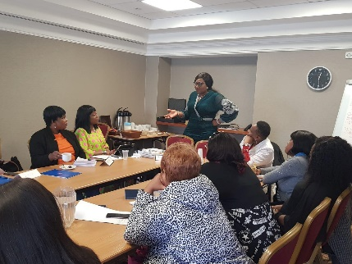

We coach intensively on best in class 21st century methods for sustainable workplace excellence

- Methods for getting recognition in the workplace
- Confidence for stretching yourself and growing
- Skills for achieving specific targets & excelling in your current role
- Coaching and finding joy, satisfaction, and fulfilment in what you do
- Networking opportunities for leveraging your peers and mentors
- Techniques for developing your personal brand awareness
An Accessible Network

We provide unrestricted access to our strong 2000+ network of members, expert mentors, and coaches

- Access to a successful 2000+ network of BME professionals
- A platform for surrounding yourself with the right professional support network
- A hub for surrounding you with by the right people
- Experts with access to the right career information & systems
- Support network to empower, champion and support your career progression
- A platform for accessing the right calibre of top mentors

Access to Industry Experts
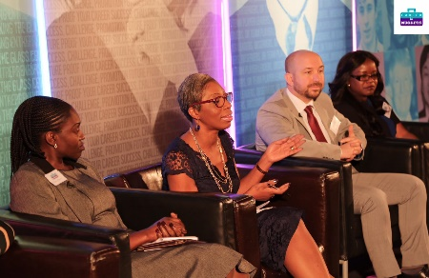

We offer opportunities for questions, answers, meeting and networking with industry experts or sponsors

- Opportunity for obtaining a suitable career coach
- Platform for finding career experts and sponsors
- Encouragement for thriving and in a nurturing environment
- Skills for increased profile in the workplace
- Techniques for increased visibility in the marketplace
- An accessible hub for embracing the right solutions and support systems

TIMETABLE & OUTCOMES

Weeks | Topics | Description
Pre-Planning | Career Planning & Gap Analysis | - Career Vision Board  - Career Goals  - Your Purpose
1 | Maximising Career Opportunities | - Transferable skills  - Career options  - Transitioning
2 | Leadership & Managing | - Leadership Styles  - Managing Upwards and Downwards  - Leaders of Leaders
3 | Leadership Mindset Makeover | - Thinking traps and hacks  - Strategic Thinking  - Dealing with Self-limitations & Resilience
4 | Visibility in the Marketplace | - Perception management  - Adding Value  - Networking Effectively
5 | Communication Skills | - Delivering with impact  - Influencing & Presenting  - Top Notch Elevator Pitch
6. | Conflict Management | - Office & Remote Politics  - Managing Differences  - Influencing & Persuading Skills

CAREER NUGGETS - THE ACADEMY

WORKPLACE EXCELLENCE PROGRAMME

